//BLUE TOWN - ROSE - DAY//
Snow swirled around them, the cold wind biting at their faces as Ragul and Dhanasree stood facing each other. Ragul’s eyes held confusion, while Dhanasree’s gaze was intense, her face set with urgency.
Dhanasree: (shouts) Rahul!
Ragul turned, surprised, his eyes searching Dhanasree’s face for answers.
Ragul: (confused) Dhanasree… Yenna yedam idhu? Ipdi-oru yedam irukku-nu unaku yerkanavey theriyuma?
Dhanasree: (nodding, her voice low but firm) Theriyum. Indha planet peru Glacia.
Ragul’s mind races. "Planet-ah?" he thought. "Appo naa completely vera oru planet-la irukena? Yepdi idhu nadandhurukum? (realizing) Aaama… Aaama… Nithish-dhaan kadasiya yennamo pannan. Nalla nyabagam iruku. Aana yepdi? Appo idhellam iva yerkanavey plan pannadha yenna?!" His chest feels tight. "Vera yenna yellam ivaluku theriyum? Appo ivaluku yennoda power pathi-yellam theriyuma?!” He looks at her with a frightened gaze “Modhala yaaru iva?"
He stares at Dhanasree, still in shock, but slowly calming him down by taking deep breaths. "Innoru pudhu planet… Manushanga vazha mudiyara innoru planet…" A feeling of excitement starts to mix with his surprise. He looks around, the cold wind stinging his cheeks, but all he can feel is awe. "Indha edam… idhu… romba different-ah, amazing-ah iruku! Idhu maari na oru yedatha TV-la kooda paathadhu illa." He feels a spark of gratitude. "Yethana peruku indha madhiri oru pudhu planet-ku poga vaipu kedachiruku?"
Ragul (to Dhanasree): (shocked) Planet-ah? Appo idhu Boomi illaya?
Dhanasree: (shakes her head, eyes serious) Illa.
Ragul (tense, shouting)): Appo nee Alien-ah?!
Dhanasree: Dei mundam un-kooda dhana moonu maasam-ah college padichitu irukan.
Ragul: Inga vera yedachu monsters yellam iruka yenna?
Dhanasree: Monsters-lam yedhuvum illa. Inga irukavanga yellarumey romba nallavanga. Ketta visayam yedhuvumey theriyadhavanga.
Ragul: Inga yennaala evlo neram ipdiye iruka mudiyum? Moochu thenari saava matana?
Dhanasree: Adhellam onnum aagadhu. Idhu Earth maari-dhan. Aana yenna, indha ulagam full-ah pani-ah dhaan irukum.
Ragul: Seri, indha planet peru Glacia-na.. Idhu yendha yedathula iruku… Solar system-la dhaan iruka yenna? Illa vera galaxy-ah? Earth-la irundhu evlo dhooram?
Dhanasree: Iru-iru. Indha planet yenga irukun-nu yenaku theriyadhu, aana ipdi oru planet iruku-nu yenakku yerkanavey theriyum.
Ragul: Idhellam unaku yerkanavey theriyum-na, munnadiye yen sollala nee? “Yenna nambu” “Yenna nambu” apdi-nu soldradhuku badhula… ipdi oru yedam irukunu sollirukalam-la? Indha yedathula yenna safe-uh? Yenna safe-illa nu yedachu therinjirukum-la? Oru-vela inga iruka animals-yellam manishangala sapdra type-ah irundha?!
Dhanasree: Munnadiye unga-kitta solladhadhuku yenkitta reason iruku. Aprom Indha yedatha pathi yenaku nalla theriyum. Inga chinna chinna poochi-la irundhu periya periya animals varaikum, yedhvum onnum pannadhu. Idha vida mukkiyamana visayam yenna-na inga irukavangaluku sanda, sogam, depression, stress-uh yedhuvumey theriyadhu. Inga irukuravangaloda orey purpose yennana, mudinja alavukku happy-ah irundhu, seekram sethu, God-kitta poradhu dhaan.
Hearing Dhanasree’s words, some memories flashed in Ragul’s mind:
[Shreesha: (blinks) Adhuku aprom innum kandupudikala. Aana adhellam yengaluku theva illa, adhukulla naanga sethuruvomey!]
[Aadarsh: Appadiya!! Appo yenaku oru-dhadava senju kaatunga!]
Ragul (to himself): Adhanala-dhaan, yenna saava solli ketutu irundhangala…
Aadarsh (who was listening to their convo): Aama!
Ragul (to Aadarsh): Dei amaidhiya irra thailee
Aadarsh: (laughing) Thailee-ah! (laughs again) Shreesha! Thailee! Nalla iruku peru.
Dhanasree gave a serious look at Ragul. Noticing her anger, Ragul acts as if he ignored what he said.
Ragul: Seri mela sollu.
Dhanasree: Adhu mattum illa-ma avunga nenachalum saava mudiyadhu.
Ragul: Yenna soldra?!
Dhanasree: Avunga kitta “Magic Guard” iruku.
Ragul: Apdina?
Dhanasree: Shreesha inga va.
Dhanasree (to Ragul): Adhu oru protection madhiri. Veliya irundhu yenna adi vilundhalum, adhu yevlo perusa irundhalum, avunga udambuku yedhuvum aagadhu..
Shreesha stood near Dhanasree, smiling.
Shreesha: Yennoda per ungaluku yeppadi theriyum?
She instantly slapped Shreesha.
Shreesha: (playful) Ai! Yenna panra? Idhu yenna game?
Ragul gets reminded of how Aadarsh fell down and did not get even a single injury.
[ Aadarsh: (smiling) God-friend! Na correct-ah kudichana?

Ragul stood there, speechless, staring at Aadarsh in disbelief.]
Dhanasree (to Ragul, ignoring Shreesha): Ippo dha oru important aana visayam solla poren, nalla ketuko.
Ragul moved closer to Dhanasree.
//Cut to//
//RED TOWN - LILY// || //BLUE TOWN - ROSE//
White-dressed girl and Nithish were picking up fruits together.

Nithish: Unnala power use panna mudiyadha?

White-dressed girl nodded her head that she can’t use.

Chubby man: Ava… porakum-bodhey power llama dhaan porandhaa. Naanum porakkum bodhey… ipdi dhaan… (gestures his chubby body) porandhan; unique-ah irundhom. Adhanala-dhaan nanga rendu perum friends agitom.

White-dressed girl: Elijah! Summa iruka maata.

They put every fruit inside the carriage. The white-dressed girl closed the carriage door.

Nithish: (to himself) Elijah va…. Appo ivaloda peru yenna? Aamala… na innum kekavey illa ivakitta!

White-dressed girl (to Nithish and Elijah): Na varan.

|| Ragul stood in disbelief. He kept both his hands in his mouth in shock.

||Dhanasree (firm, her fists tightening) Avana kolradhudhan ipo namma kitta iruka orey option.

Nithish: (to White-dressed girl) Un peru–

Suddenly a sword was fast swung behind Nithish, quickly the White-dressed girl pushed Nithish aside to save him.

|| Ragul (terrified): Yaru avan?

Nithish was stunned and froze for a moment, realizing he escaped just by a second.

|| Dhanasree: Avan… black colour armor poturupan.

He was a person covered in sleek and black armor, featuring sharp angles and a futuristic design. He wore a helmet that has purple spikes.

|| Dhanasree: Kaila periya blue colour kaththi vechurupan

He wielded a large sword with a blue faint glowing blade, that contrasts sharply with the dark armor.

Nithish: (astonished) Yaaru ivan?!

|| Dhanasree: (frightened) Namma seekram Nithish-aiyum Dharshna-vayum kandu-pidikanum. Illana, avan avangalaiyum konnuduvan.

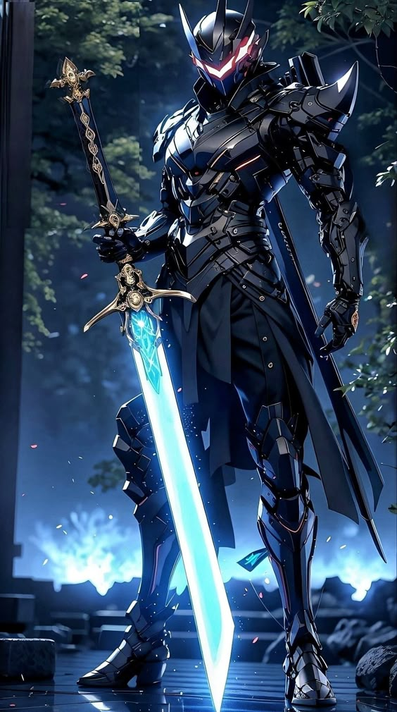

The armored guy swung his sword fast, the blade cutting through the air as Nithish threw himself to the side, barely avoiding it. He stumbled, his breathing heavy, struggling to keep his balance. Around him, people had started to gather, drawn in by the commotion. Among them was Elijah, who paused mid-bite from a piece of fruit, his eyes widening with interest.
The armored guy took another swing, and Nithish dodged again, each movement feeling harder than the last. He broke into a run, the metal cuffs on his wrists clanking with every step.
Nithish (to himself): Romba vegam-ah irukan!
More people gathered over, abandoning their games to see what was happening. Nithish glanced over his shoulder, the armored guy right behind him, just a few paces slower.
Nithish looked at the crowd, noticing the gossips and amused expressions.
Nithish: (to himself, frustrated) Ivunga yenna sirichitu irukanga?! (shouting) Yaaravadhu yenna kaapathunga!

An older man in the crowd caught his eye and shouted back: Neenga veladunga! Naanga paakurom!!

Nithish’s face twisted in confusion and frustration.

Nithish :(shouting as he ran) Ivan yenna kolla poraan!

He glanced back and saw the armored man approaching, his face cold and resolute. Panic surged through Nithish, and in a quick decision, he grabbed a handful of snow and threw it at the armored guy’s face, buying himself a few crucial seconds as the guy wiped it away.
Nithish ducked behind a tree, his heart pounding. “Ippo na yenna pandradhu?!”
Nithish: (to the armored guy, panicking) Yedhuku yenna kolla vara!

The armored guy didn’t answer. He just kept advancing fast, his footsteps crunching through the snow.

Nithish: (stressing) Oru nimisham pesi theethukalam.

Nithish was scared as the armored guy charged towards him at a fast pace. The black figure’s presence made his heart pound.

Breathing heavy, Nithish quickly ran up to a man nearby, grabbing his arm.

Nithish: (pleading) Konjam udhavi pannunga… avar-kitta irundhu kaapathunga.

The man ignored him, a slight smile on his face. “Illa illa. Neenga veladunga, paaka nalla iruku.”

Nithish stared at him, his face a mix of shock and anger.

Nthish: (pleading) Unga power use panni ipdi-ipdi (gesturing his hand as if doing telekinesis) yedachu panni kaapathungaaaa!!

That man: (smiling) Na aprom vandhu sendhukuran unga kooda.

Frustrated but determined, Nithish turned to others in the crowd, hoping someone—anyone—would care enough to help.

Nithish: Akk (gasps)… akka… akka… konjam help pannunga!

A woman smiled, shaking her head. “Nee veladu pa!”

Nithish: Anna, neenga-lavadhu…

Another man just smirked, clearly entertained. “Nee-”

Nithish shouted desperately “Yaaravadhu udhavungalen!!!”

The people stood around, their awe-ness and curiosity increased as Nithish shouted.

Nithish's stomach dropped as he understood that no one was going to come to his aid. The armored figure was approaching, his shadow falling over him.

Nithish: (frightened) Indha kanavu yen ivlo mosama iruku?!

Nithish trembled as he saw the shadow and turned just in time to see the sword descending. He attempted to leap aside, but it was too late—the blade nicked his back, ripping through his shirt and leaving a painful cut.

Nithish: (suffering in pain) Hsssss… Aaah! Valikudhuu!! AAh! Maaa!!
Nithish stumbled, reaching back to hold his wounded back, but his cuffed hands couldn’t reach. He struggled to break the cuffs with his bare hands, but it was no use.
Nithish (to himself): Aaah! Valikudhu… (realizing) Idhu.. idhu… kanavu illa…

The armored guy stood over him, raising his glowing blue sword high in the air.

Nithish: (eyes widened in shock): Idhu nejam!
Just as the blade came down, Nithish turned, trying to block it with his cuffed wrists. But suddenly, a platinuml sword with a golden handle blocked the strike. The girl dressed in white had come to his rescue. She jumped and kicked the armored guy, forcing him to stumble back. Then she grabbed Nithish’s hand, helping him to his feet.
She stood tall, her black belt and scarf flying in the wind as snow swirled around them.
Nithish looked at her, stunned. The armored guy came at Nithish again, ignoring the girl. She moved quickly, kicking the armored guy’s leg, knocking him down right in front of Nithish.
The girl took Nithish’s hand and began to run, but the armored guy grabbed Nithish’s leg, pulling him down. She slashed at his hand, barely damaging the armor, but she kicked and pressed down on his wrist until he let go of Nithish’s leg.
The armored guy swung his sword at Nithish’s legs with the other hand, scraping through the snow. The girl pushed Nithish out of the way to help him dodge, resulting in him falling..
White-dressed girl: (to Nithish) Gavanama iru!

The armored guy got to his feet again.

White-dressed girl: (to Nithish) Yen pinnadiye va! (Nithish, still in shock, nodded slightly)

They both started running, with Nithish suffering in pain due to the wound.

Nithish: Aaah!

The armored guy chased them as they ran to the large wolf tied to the carriage. It had purple dark body white white stripes. The girl began untying the ropes from one side, and Nithish quickly copied her on the other. The armored guy was getting closer.

White-dressed girl: (to Nithish) Kaiya neetu!

Confused, Nithish stretched out, and she slashed his cuffs off.

She then climbed onto the wolf’s back. Nithish looked hesitant.

White-dressed girl: Vandhu yeru!

Nithish quickly climbed up behind her.

White-dressed girl: (tapping on the wolf) Po!

The wolf took off, and Nithish grabbed onto the girl’s waist to steady himself.

White-dressed girl: Gettiya pudichiko!

The armored guy tried to chase them, but the wolf was fast, and they sped across the vast valley, leaving him far behind as they entered the open plains. Realizing they had escaped, the armored guy put his sword back into his sheath that was fixed to his back of armor.

